ADVANCED SUBSCRIPTION & MEMBERSHIP PLATFORM

Raja Irfan Ahmed
Muhammad Ammar

Supervised By
Dr. Zohaib Ahmed
In Collaboration with Eziline

Submitted for the partial fulfillment of BS Computer Science degree to the Faculty of Engineering & Computing
NATIONAL UNIVERSITY OF MODERN LANGUAGES ISLAMABAD

NOVEMBER, 2026

ABSTRACT
The Advanced Subscription and Membership Platform is a web app. It helps content creators manage their paid membership areas. Users can subscribe directly to individual creators instead of a central catalog. The project lets creators control their work. They can set prices and choose who sees each item. It also seeks to transition subscribers from free browsing to paid memberships. Most membership services group creators together. They use one set of rules and take a cut from payments. This limits creators’ tier organization and separates their audiences. This project solves the problem of a missing membership model. It lets each creator set their own membership structure. Also, it keeps the billing process simple.
The system employs Next.js 15, React 19, and TypeScript. Clerk manages authentication, while PostgreSQL stores data. Stripe handles recurring billing through hosted Checkout and the Customer Portal. Cloudflare R2 is used for file storage. Three roles are supported: a subscriber can follow a creator for free or choose Basic or Premium tiers, accessing gated videos, articles, and downloadable files monthly. Creators publish content, set tiers, and review subscribers, revenue, and analytics. Administrators manage users, content, payments, and settings. The system checks each item's tier against the subscriber's tier, recording paid access only Stripe's webhook signature.
The platform underwent manual black-box and functional testing on a standard development machine. Major workflows were tested, including sign-up, verification, following a creator, tier payment in Stripe test mode, downloading files, cancelling plans, and administrative actions like suspending accounts. The observed behavior aligned with expectations, confirming the access rules, billing flow, and role restrictions function as intended.
The project has clear limitations. It operates in Stripe test mode with a single database, lacks an automated test suite, and does not support creator payouts or a plan unlocking all creators. Future work could introduce automated testing, enhance analytics, add creator payout handling, and prepare the application for production. Despite these limits, the system effectively demonstrates a complete per-creator membership model from sign-up to paid access and administration.

CERTIFICATE

Dated: _____________

Final Approval

It is certified that the project report titled ‘ADVANCED SUBSCRIPTION & MEMBERSHIP PLATFORM submitted by Raja Irfan Ahmed and Muhammad Ammar for the partial fulfillment of the requirement of “Bachelor’s Degree in Computer Science” is approved.

COMMITTEE

Dr. Ata Ullah
Dean FEC Signature: ______________

Dr. Fazli Subhan
HoD Computer Science Signature: ______________

Mr. Zain ul Abideen
Head Project Committee Signature: ______________

Dr. Zohaib Ahmed
Supervisor Signature: ______________

DECLARATION
We hereby declare that our dissertation is entirely our work and genuine/original. We understand that in case of discovery of any PLAGIARISM at any stage, our group will be assigned an F (FAIL) grade and it may result in withdrawal of our Bachelor’s degree.

Group Members Signature
- Raja Irfan Ahmed
- Muhammad Ammar

PLAGIARISM CERTIFICATE
This is to certify, that a project, the title of which is “Advanced Subscription & Membership Platform”, which is submitted here in the form of a project for the award of the “Degree of Bachelors” in “Computer Science” has been prepared. It is the outcome of the initial work of Raja Irfan Ahmed and Muhammad Ammar supervised and guided by me. The work embodied in this project has not been done earlier for the basis of award of any degree or compatible certificate or similar title of this for any other diploma/examining body or university to the best of my knowledge and belief.

Turnitin Originality Report
ID: 3000859844
Processed on: 20-Jul-2026 9:59 PM PKT
Word Count: 21151

Similarity Index: | 8%
Similarity by Source:
Internet Sources: | 4%
Publications: | 3%
Student Papers: | 6%
Date: 22/7/2026 |  | Dr. Zohaib Ahmed

TURNITIN ORIGINALITY REPORT
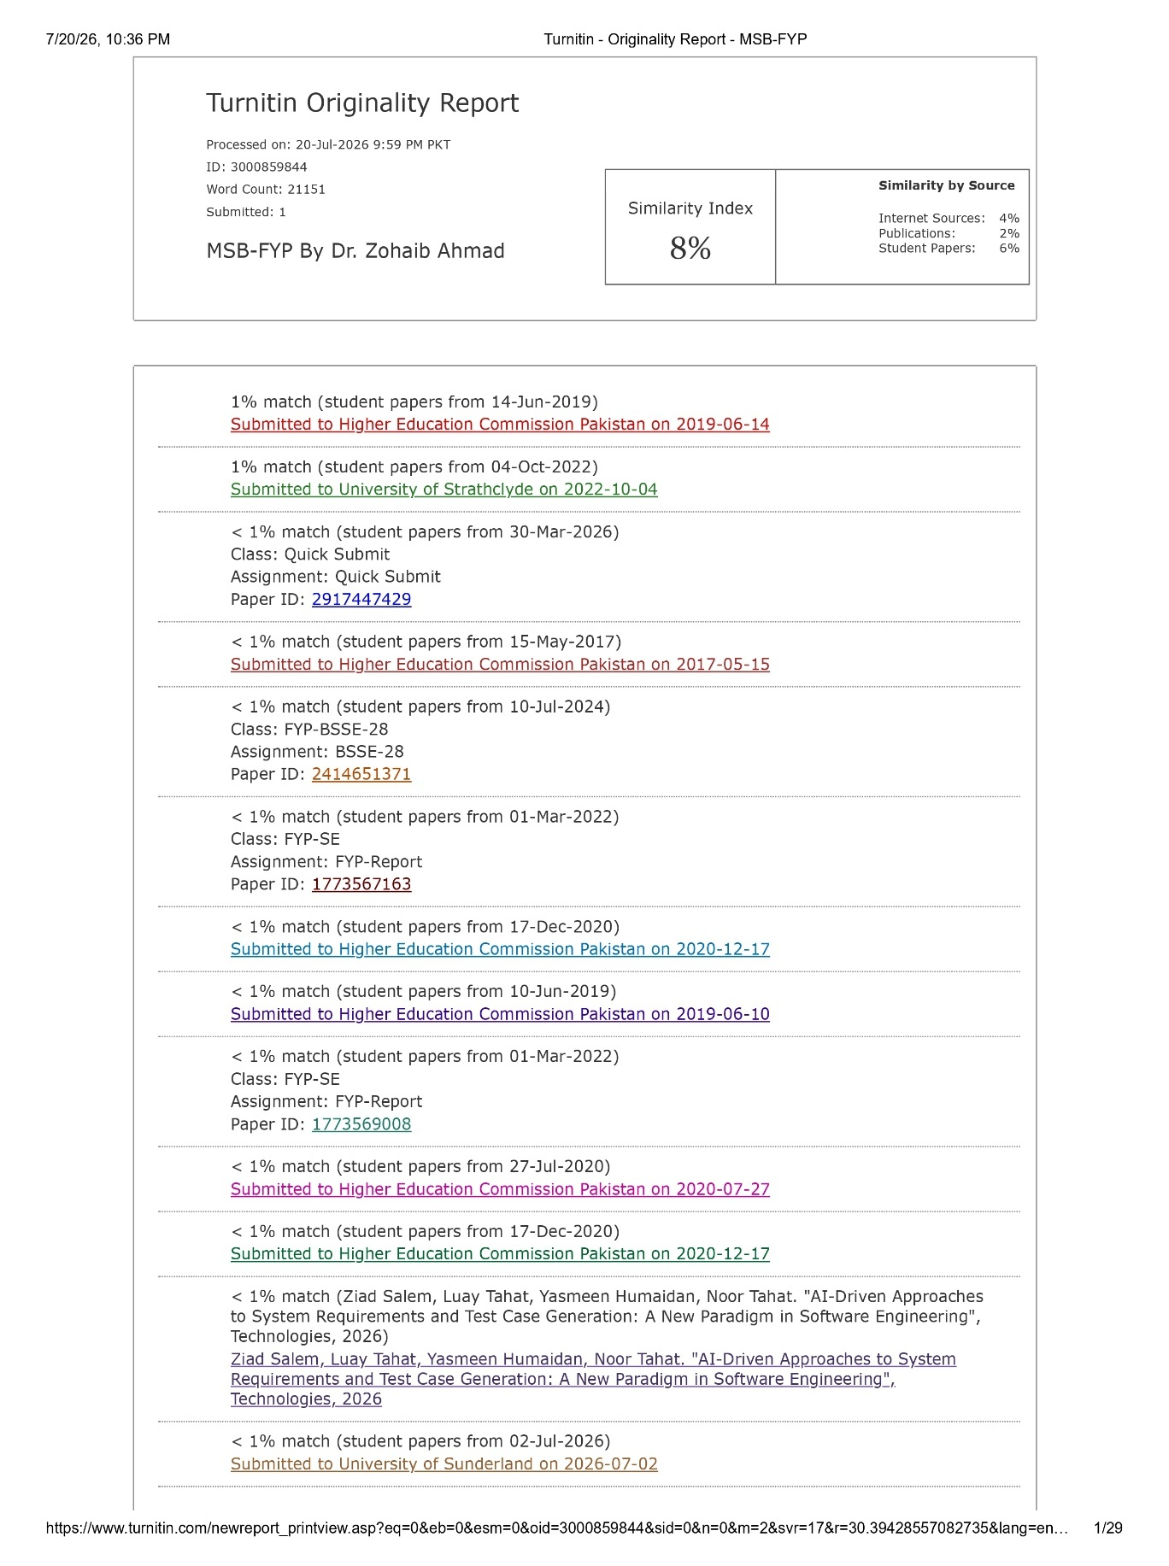

TABLE OF CONTENTS
Chapter Page
1 CHAPTER 1 INTRODUCTION xi
1.1 Introduction 1
1.2 Project Domain 1
1.3 Problem Identification 2
1.3.1 Proposed Solution 2
1.3.2 Objectives 2
1.3.3 Scope of the Project 3
1.4 Effectiveness / Usefulness of the System 3
1.5 Resource Requirement 4
1.5.1 Hardware Requirement 4
1.5.2 Software Requirement 4
1.5.3 Data Requirement 5
1.6 Report Organization 5
2 CHAPTER 2 BACKGROUND AND EXISTING SYSTEMS 1
2.1 Related Literature Review 7
2.2 Related Systems/Applications 8
2.3 Identified Problem from Existing Work 9
2.4 Selected Boundary for Proposed Solution 10
3 CHAPTER 3 REQUIREMENT SPECIFICATION 7
3.1 System Specification 12
3.2 System Modules 12
3.2.1 Authentication and Role Management 13
3.2.2 Creator Workspace and Content Management 13
3.2.3 Subscription and Billing 13
3.2.4 Content Access and Downloads 13
3.2.5 Administration 14
3.2.6 Notifications 14
3.3 Functional Requirements/Software Features 14
3.3.1 Account Registration and Sign-in 14
3.3.2 Following and Subscribing to a Creator 14
3.3.3 Tier-Based Content Access 14
3.3.4 Protected File Downloads with Quota 15
3.3.5 Creator Content and Plan Management 15
3.3.6 Administrative Oversight 15
3.3.7 In-App Notifications 15
3.4 Non-Functional Requirements 15
3.4.1 Security 15
3.4.2 Usability 15
3.4.3 Reliability 15
3.4.4 Performance 16
4 CHAPTER 4 System Modeling and Design 17
4.1 System Design and Analysis 17
4.2 Use Case Diagram 17
4.3 Full Dress Use Case 19
4.4 Activity Diagram 20
4.5 Data Flow Diagram 22
4.6 System Sequence Diagram 23
4.7 Sequence Diagram 25
4.8 Design Class Diagram 25
4.9 Architectural Diagrams 26
4.9.1 Interface Design 26
4.9.2 Component Level Design 27
4.9.3 Deployment 28
5 CHAPTER 5 System Testing and Validation 17
5.1 System Testing 42
5.2 Testing Techniques 42
5.2.1 Black Box Testing 42
5.2.2 Functional Testing 42
5.3 Test Cases 43
5.3.1 Test Case 1: Pay for a Paid Tier 44
5.3.2 Test Case 2: Download Quota 44
5.4 Non-Functional Requirements 45
6 CHAPTER 6 Conclusion 43
6.1 Conclusion 53
6.2 Limitations and Future Work 53
References 54

LIST OF FIGURES
Figure Caption Page
Figure 4.1: Main Use Case Diagram 18
Figure 4.2: Activity Diagram 21
Figure 4.3: DFD Level 0 22
Figure 4.4: DFD Level 1 23
Figure 4.5: System Sequence Diagram 24
Figure 4.6: Sequence Diagram 25
Figure 4.7 Class Diagram 26
Figure 4.8 Interface Design Diagram 27
Figure 4.9 Component Level Design 27
Figure 4.10 Deployment 28

LIST OF TABLES
Table Caption Page
Table 1.1 Hardware Requirements 4
Table 1.2 Software and Tools 4
Table 2.1 Summary of Reviewed Literature 8
Table 2.2 Summary of Existing Systems 9
Table 4.1: Full Dress Use Case for Subscribe to a Creator Plan 19
Table 5.1 Summary of Test Cases 43
Table 5.2 Test Case for Paid Checkout 44
Table 5.3 Test Case for Download Quota 44
Table 5.4 List of Common Non-Functional Requirements 45

CHAPTER 1
INTRODUCTION

Introduction
The way people pay for online content has changed. Instead of buying a single file once, audiences now pay a recurring fee to support the people who make videos, write articles, and share downloadable material. This model, often called the creator subscription economy, rewards steady output and a direct relationship between a maker and the people who follow the work. Several large services proved that the idea works at scale, but most of them were built around one central catalogue and one company that keeps a share of every payment. A creator who joins such a service accepts its rules, its cut, and its way of grouping members. That trade-off is acceptable for some, yet it leaves little room for a creator who wants a private space with pricing and access under their own control.
The Advanced Subscription and Membership Platform was built to study and solve a narrower version of this problem. It gives each creator a separate space where they publish their own videos, articles, and files, and it lets a subscriber pay that specific creator for access rather than paying the site as a whole. A person can follow a creator for free, or move up to a paid tier when they want more. The platform tracks who can open each item, collects payments through Stripe, stores files on cloud object storage, and gives administrators the tools to keep the service healthy. Compared with a single global catalogue, this per-creator design keeps each creator's audience, pricing, and content separate, which makes the membership relationship easier to reason about and easier to control.

Project Domain
This project sits in the domain of full-stack web development applied to subscription and membership management for digital content. It brings together several areas that usually sit apart. It handles user authentication and role management, recurring billing, access control based on paid tiers, and cloud file storage, and it presents all of this through a web interface backed by server-side application logic. The central problem in this domain is controlled access to paid digital content. A creator uploads material and marks how much access each item needs, and the platform must make sure that only subscribers with the right tier can open or download that material, while still letting the public see previews. The domain therefore combines billing correctness with careful permission checks, because a mistake in either area either blocks a paying member or exposes paid content to someone who has not paid. The project title matches this domain directly, since the system is an advanced subscription and membership platform whose main concern is who may access what, and on what terms.
Work in this domain has to respect the boundary between the code that runs in the browser and the code that runs on the server. Anything sent to the browser can be read or changed by the user, so an access decision that only hides a button is not a real control. For this reason the project places every access check on the server and treats the browser only as a way to show results and collect input. It also has to work with services it does not own, since authentication, payment, and storage are provided by outside companies. This means the design must handle events that arrive from those services and must stay correct even when a call to one of them is slow or fails, which shapes many of the decisions described later in this report.

Problem Identification
Creators who want to earn from their work face problems that current tools solve only in part. Popular membership services place every creator inside one large system, take a percentage of each payment, and often group members using a structure the creator cannot fully change. A creator on such a service cannot easily keep their audience separate from everyone else's, and the payment rules are fixed by the host. On the technical side, building a membership site from scratch means solving authentication, recurring billing, file protection, and access control at the same time, and getting any one of these wrong causes real harm. If billing state and access state drift apart, a member who has paid may be locked out, or a member who has stopped paying may keep access. If files are served directly, a shared link can leak paid material to people who never subscribed. These issues explain why a smaller, self-contained membership model, with clear per-creator access rules and a billing flow that only grants access after payment is confirmed, is worth building and studying.

Proposed Solution
The proposed solution is a web application where each creator owns a membership space and each subscriber holds a separate relationship with every creator they join. When a subscriber follows a creator for free, the system records a free membership for that pair. When a subscriber pays for Basic or Premium, the system starts a Stripe Checkout session, and it grants paid access only after Stripe confirms the payment through a signed webhook. Every piece of content carries a required tier, and the server compares that tier against the subscriber's current tier for the owning creator before it serves the item. Files are never handed to the browser as public links; instead they are streamed as attachments after an access check, and downloads are counted against a monthly quota. Administrators sit above these flows and can suspend accounts, cancel or reactivate subscriptions through Stripe, refund or retry payments, and place the whole site in maintenance mode. This design keeps billing and access tightly linked and keeps each creator's membership separate from the rest.

Objectives
- To design a per-creator subscription model where access is decided separately for each creator and tier.
- To develop secure authentication and role handling for subscribers, creators, and administrators.
- To integrate recurring billing through Stripe so that paid access is granted only after payment is confirmed.
- To protect paid files by serving them as access-checked attachments and by enforcing a monthly download quota.
- To provide creators with tools to publish content, manage tiers, and review subscribers, revenue, and analytics.
- To validate the developed system through manual functional testing of its main workflows.

Scope of the Project
The system covers the full membership cycle for digital content. It allows a visitor to register, verify an email, and sign in, and it supports Google sign-in and password reset. It lets a subscriber browse public creator pages, follow a creator for free, and pay for a Basic or Premium tier through Stripe Checkout. It gives a subscriber a library of gated videos, articles, and files, a subscription page, access to the Stripe Customer Portal, an account area, and an in-app notification inbox. It gives a creator a workspace to publish video, article, and file content, to set Free, Basic, and Premium tiers, and to view subscribers, revenue, and analytics. It gives an administrator control over users, creators, content, plans, subscriptions, payments, notifications, and platform settings. The system runs as a web application intended for desktop and mobile browsers. It works against Stripe test mode and a single PostgreSQL database, and it does not handle creator payouts or a single plan that unlocks every creator at once.

Effectiveness / Usefulness of the System
The system is useful because it keeps the membership relationship simple and safe for both sides. A creator gains a private space with three clear tiers and direct control over what each tier unlocks, without sharing a catalogue with unrelated creators. A subscriber gains a clear route from free following to paid access, with a familiar and trusted payment screen provided by Stripe, and with a record of downloads that keeps usage fair. Because access is always checked on the server and paid access is only written after Stripe confirms a payment, the system avoids the common failure where billing and access fall out of step. The download quota and attachment-only file delivery reduce the risk of paid material spreading through shared links. For a learner or a small creator, this makes the platform a practical starting point, and for the purpose of this project it shows how billing, authentication, storage, and access control can be combined into one coherent service.
The tier design also keeps the offer easy to understand. The Free tier costs nothing and is reached by following a creator, and it allows a small number of file downloads each month along with free articles and video previews. The Basic tier is a paid monthly plan that opens the free and basic content and raises the monthly download limit. The Premium tier is a higher paid plan that opens every tier of content from that creator and removes the download limit. Because these three levels apply per creator, a subscriber can hold a different tier with each creator they join, which mirrors how people support different makers by different amounts. This clarity is part of what makes the system practical for real use rather than only as an academic exercise.

Resource Requirement
This section lists the resources used to develop and run the system. Because the platform is a web application, the requirements fall into three parts, namely the hardware needed for development and execution, the software and tools used to build it, and the data the system stores and processes. Table 1.1 lists the hardware and Table 1.2 lists the software and tools.

Hardware Requirement
The application is not heavy on the client side, so it runs on any modern computer or phone with an up-to-date browser. Development and local execution need a machine able to run the Node.js toolchain and a local PostgreSQL server at the same time. The configuration in Table 1.1 is sufficient for development and testing.
Table 1.1 Hardware Requirements
Component | Minimum Specification
Processor | Dual-core 2.0 GHz or higher
Memory (RAM) | 8 GB
Storage | 10 GB free disk space
Network | Stable internet connection for Clerk, Stripe, and Cloudflare R2
Client device | Any device with a modern web browser

The system was built with a modern JavaScript and TypeScript stack. The application framework is Next.js 15 with React 19, written in TypeScript. Data is stored in PostgreSQL and reached through the node-postgres driver. Authentication is handled by Clerk, billing by the Stripe SDK, and file storage by Cloudflare R2 through the S3-compatible AWS SDK. Styling uses Tailwind CSS. The tools used during development are listed alongside the runtime software in Table 1.2.

Software Requirement
Table 1.2 Software and Tools
Software / Tool | Purpose
Next.js 15 and React 19 | Application framework and user interface
TypeScript | Typed application language
Node.js | Server-side runtime
PostgreSQL with node-postgres | Relational database and access driver
Clerk | Authentication and user management
Stripe SDK | Recurring billing, Checkout, and Customer Portal
Cloudflare R2 with AWS S3 SDK | Object storage for media and files
Tailwind CSS | Interface styling
Git, VS Code, Stripe CLI | Version control, editing, and local webhooks

Data Requirement
This project is not based on machine learning, so it does not need a training or testing dataset. The data it works with is operational data created by its own users. This includes user and role records, creator profiles, subscriber profiles, plans, content records with their required tier, subscription records for each subscriber and creator pair, payment records synced from Stripe, notifications, analytics snapshots, and platform settings. All of this data is stored in the PostgreSQL database and is created as people use the system, so no external dataset is required.

Report Organization
This report is organised into six chapters. Chapter 1 introduces the project, its domain, the problem it solves, the objectives, and the scope. Chapter 2 reviews related literature and existing systems and states the gap this project fills. Chapter 3 describes the system requirements, the main modules, and the functional and non-functional requirements. Chapter 4 presents the system models and design, including the use case, activity, data flow, sequence, class, and architectural diagrams. Chapter 5 covers system testing, the testing techniques used, and the test cases and their results. Chapter 6 concludes the report and discusses the limitations of the current system and the work that can be done in the future. A list of references appears at the end.

CHAPTER 2
BACKGROUND AND EXISTING SYSTEMS

The problem under consideration is how a single platform can host many independent creators while keeping each creator's paid content, pricing, and audience separate and secure. This chapter looks at the background of that problem and the systems that already try to solve parts of it.
The chapter is organised into four sections. Section 2.1 reviews related literature on access control, software-as-a-service architecture, and subscriber retention and analytics. Section 2.2 discusses existing membership systems and their strengths and weaknesses. Section 2.3 states the problems identified from that existing work, and Section 2.4 defines the boundary chosen for the proposed solution.

Related Literature Review
The first area of related work is access control, which decides who may perform which actions in a system. Sandhu, Coyne, Feinstein, and Youman (1996) set out a family of role-based access control models in which permissions are attached to roles and users are then assigned to those roles rather than being granted rights one by one. This idea maps directly onto the present project, which defines the roles of subscriber, creator, and administrator and gives each role its own set of actions. The same model also supports the per-item access rule, since the required tier on a content item acts as the permission that a subscriber's role and tier must satisfy before the server serves the item. Basing the design on an established access control model gives the permission structure a firm footing rather than an informal one.
The second area is the architecture of software that serves many customers from one running system, often called software as a service. Chong and Carraro (2006), in a Microsoft technical publication, describe how such software should be configurable, efficient across many tenants, and able to scale as the number of users grows. This is relevant because the platform hosts many independent creators inside one application and one database, and it must keep each creator's space separate and configurable while sharing the same code and infrastructure. Their treatment of multi-tenant design supports the choice to separate per-creator data by ownership within shared tables rather than to run a separate system for each creator. Because this source is an industry technical paper rather than a peer-reviewed study, it is treated as practical architectural guidance rather than as experimental evidence.
The third area is subscriber retention and the analytics used to understand it. Ascarza (2018), writing in the Journal of Marketing Research, uses field experiments and machine-learning methods to show that aiming retention effort at the customers most likely to leave can be ineffective, and that the value of a retention action depends on how a customer responds to it rather than on churn risk alone. This finding gives a reason for the platform to collect engagement and subscription analytics for creators, since sound retention decisions need evidence about how subscribers actually behave. The present project does not build a retention model, so this source supports the rationale for the analytics feature rather than a particular algorithm.
These three sources cover access control, service architecture, and retention analytics, which are the areas where existing research maps cleanly onto the project. Two further objectives, namely recurring payment handling and automated renewal notifications, are engineering concerns that this project meets by following the official documentation of the payment provider rather than a research paper, since these are matters of correct integration rather than open research questions. Section 2.2 therefore turns to existing systems to compare how these payment and membership features are offered in practice. Table 2.1 summarises the three reviewed sources
Table 2.1 Summary of Reviewed Literature
Year | Authors | Contribution | Techniques | Limitations/Remarks
1996 | Sandhu, Coyne, Feinstein and Youman | Role-based access control reference models linking users, roles, and permissions | Formal RBAC models with roles and role hierarchies | Predates modern web and SaaS; a general model rather than a web-specific design
2006 | Chong and Carraro | Architecture strategies for configurable, multi-tenant, and scalable software as a service | Architectural analysis in an industry technical publication | Industry white paper, not peer-reviewed; guidance rather than a controlled study
2018 | Ascarza | Evidence that targeting high-risk customers for retention can be ineffective | Field experiments and machine-learning analysis | Set in marketing; not specific to per-creator content platforms

Related Systems/Applications
Several existing systems already offer membership or subscription features, and each shows useful ideas as well as limits that this project responds to. Patreon lets creators offer paid membership tiers and post content for members. It works well for many creators, but it keeps every creator inside one large platform, charges a platform fee on earnings, and shapes how tiers and pricing are presented. Substack focuses on paid newsletters and gives writers a simple way to charge readers a monthly or yearly fee. It is strong for writing and email delivery, yet it is centred on newsletters rather than mixed media libraries with per-item access tiers.
Ko-fi and Memberful offer further points of comparison. Ko-fi supports one-off tips, memberships, and small shops, and it is easy to start with, but it is built around light support rather than tiered access to a protected content library. Memberful adds membership and paywall features to an existing website and integrates with payment providers, which is powerful, yet it usually attaches to a separate site the creator already runs rather than giving each creator a self-contained space inside one shared platform. OnlyFans provides paid access to creator content behind a subscription and handles payments at scale, but its model and audience differ from a general digital-content membership tool and it also takes a platform share. Table 2.2 summarises these systems.
Set against these systems, the project takes the parts that work well and drops the parts that limit a creator. Like the reviewed systems, it uses a trusted payment provider and offers paid tiers, since these are proven ways to collect recurring income. Unlike most of them, it keeps each creator in a self-contained space, supports a mixed library of videos, articles, and files with a required tier for each item, and does not take a share of a creator's earnings within the scope of this project. The point of the comparison is not to match every feature of a large commercial service, but to show that the smaller, focused model chosen here answers real limits seen in existing tools.
Table 2.2 Summary of Existing Systems
Year | System | Contribution | Tool/Technologies | Limitations | Applications
2013 | Patreon | Tiered creator memberships | Web platform, card billing | Central catalogue, platform fee | General creator funding
2017 | Substack | Paid newsletter subscriptions | Web platform, Stripe billing | Newsletter-centric, limited media tiers | Writers and journalists
2012 | Ko-fi | Tips, memberships, small shops | Web platform, card billing | Light access control | Small creators and donations
2013 | Memberful | Membership and paywall add-on | Web plugin, Stripe billing | Attaches to a separate site | Existing creator websites

Identified Problem from Existing Work
The systems above show two repeating limits. First, most of them place every creator inside one central catalogue and apply one fee and one set of grouping rules, which reduces a creator's control over pricing and over how their audience is kept separate from others. Second, several tools are shaped around a single content type, such as newsletters or tips, rather than a mixed library of videos, articles, and files where each item can carry its own required tier. There is also a technical concern that runs through this space, which is keeping billing state and access state in step so that a paying member is never wrongly locked out and a non-paying user never keeps access. From these observations, the improvement this project targets is a self-contained per-creator membership model that supports mixed content with per-item tiers and that ties access strictly to confirmed payment.

Selected Boundary for Proposed Solution
The proposed solution implements a focused set of functions drawn from the gaps above. It gives each creator a separate membership space with Free, Basic, and Premium tiers and lets a subscriber hold an independent relationship with every creator. It supports mixed content, since a creator can publish videos, articles, and downloadable files and mark the required tier for each item. It ties access to payment by starting a Stripe Checkout session for paid tiers and granting paid access only after a signed webhook confirms the payment, which keeps billing and access in step. It protects files by serving them as access-checked attachments and by counting downloads against a monthly quota. It also provides administrative control over users, content, payments, and settings, so the platform can be kept healthy.
Some functions are left outside the boundary of this project, for clear reasons. The system does not handle creator payouts or revenue sharing, since it runs Stripe on a single platform account and focuses on the membership and access model rather than on money movement to creators. It does not offer a single plan that unlocks every creator at once, because access is deliberately kept per creator. It runs against Stripe test mode and does not include production hosting or an automated test suite, as these fall beyond the scope of the current work and are noted as future improvements.

CHAPTER 3
REQUIREMENT SPECIFICATION

This chapter describes what the system is required to do and the parts it is built from. It sets out the system specification, the main modules that divide the work into separate units, and the functional and non-functional requirements that the software must meet.
The chapter is organised into four sections. Section 3.1 gives the overall system specification. Section 3.2 describes the system modules. Section 3.3 lists the functional requirements or software features, and Section 3.4 describes the non-functional requirements together with how each one is measured.

System Specification
The system is a web application with a server side and a browser side that share the same codebase through the Next.js framework. The server side holds the application logic, the access checks, and the connections to external services, while the browser side renders the pages and forms. Data is stored in a PostgreSQL database that holds seventeen tables covering users, creators, subscribers, plans, content, subscriptions, payments, notifications, analytics, contacts, and platform settings. External services provide three supporting functions, namely authentication through Clerk, billing through Stripe, and file storage through Cloudflare R2. The application enforces its rules on the server so that a request from the browser cannot bypass an access check, and it keeps a single source of truth for tier limits so that both the interface and the server agree on what each tier allows.
The database schema is grouped by purpose so that each concern stays in its own set of tables. Identity is held in the user profile, creator profile, and subscriber profile tables, along with small tables for creator and subscriber preferences. The catalogue is held in the plan, plan feature, and content tables, where each content row carries its required tier and its links to stored media. Billing is held in the subscription and payment tables, where each subscription is unique for a subscriber and creator pair. Supporting data sits in the notification, analytics, contact, and platform settings tables. The content model supports three types, namely video that is uploaded or linked from an external source, articles written as text, and files stored as PDF, ZIP, or RAR. File sizes are limited on both the interface and the server, with images capped at eight megabytes, video at five hundred megabytes, and downloadable files at two hundred megabytes, so that oversized uploads are rejected early.

System Modules
The system is divided into modules so that each area of work is handled by a separate, self-contained unit. This separation keeps the code easier to maintain and lets each module be reasoned about on its own. The main modules are authentication and role management, the creator workspace, subscription and billing, content access and downloads, administration, and notifications

Authentication and Role Management
This module handles sign-up, email verification, sign-in, Google sign-in, and password reset through Clerk. It assigns each user a role of subscriber or creator, and it recognises an administrator through an email allowlist held in the server configuration. Middleware checks every protected route and redirects a user who does not hold the required role. The module keeps the user's role and account status available to the rest of the system so that access checks elsewhere can rely on it.

Creator Workspace and Content Management
This module gives a creator the tools to build and manage their space. A creator can publish three kinds of content, namely video that is either uploaded or linked from an external source, articles written as text, and downloadable files in PDF, ZIP, or RAR form. Each item is given a required tier of Free, Basic, or Premium and a status of draft, published, or archived. The module also lets a creator manage plans and view subscribers, revenue, and analytics for their own space..

Subscription and Billing
This module manages the relationship between a subscriber and a creator. A free follow creates a free membership record for that subscriber and creator pair. A paid tier starts a Stripe Checkout session, and the resulting subscription record is written or updated only when Stripe sends a signed webhook confirming the change. The module records payments, supports cancellation that keeps access until the end of the paid period, and connects subscribers to the Stripe Customer Portal so they can manage cards and invoices.
Each subscription carries a status that follows the Stripe lifecycle, namely active, trialing, past due, canceled, and expired. An active or trialing subscription grants the tier it was bought for. When a payment is late, the subscription moves to past due, and the system keeps access for a short grace window rather than cutting it off at once, so that a temporary card problem does not lock out a paying member. When a subscriber cancels, the subscription is marked to end at the close of the current period, and access continues until that date before it drops back to the free level. These rules are driven by the signed webhook events, so the stored status always follows what Stripe reports rather than a guess made by the interface.

Content Access and Downloads
This module decides whether a subscriber may open or download a given item. It compares the required tier of the item against the subscriber's current tier for the owning creator, using the order Free, then Basic, then Premium. Files are never given to the browser as public links. Instead the server streams them as attachments after the access check, and it counts each download against a monthly quota that depends on the subscriber's tier for that creator.
The quota is counted over a rolling window of thirty days for each subscriber and creator pair, so the count resets gradually rather than all at once on a fixed calendar date. The Free tier allows a small fixed number of downloads in that window, the Basic tier allows a larger number, and the Premium tier removes the limit for that creator. Before a file is streamed, the server checks both the tier and the remaining quota, and it refuses the download if either check fails. Because the check and the stream happen on the server, and because the file is delivered as an attachment tied to a single request, a subscriber cannot copy a plain link and share it with someone who has not paid.

Administration
This module gives an administrator oversight of the whole platform. An administrator can view and manage users, creators, subscribers, content, plans, subscriptions, and payments. Administrative actions include suspending or restoring an account, cancelling or reactivating a subscription through Stripe, refunding or retrying a payment, and turning maintenance mode on or off. When maintenance mode is on, the public site shows a maintenance page while administrators keep access so they can turn it off again.

Notifications
This module keeps users informed through an in-app inbox. It records notices about renewals, payments, content, account changes, and system messages, and it marks each notice as read or unread. Notices are delivered inside the application rather than through email campaigns, which keeps the message history in one place for each user.

Functional Requirements/Software Features
The functional requirements describe what the system must do. They follow directly from the project scope and objectives, and they cover account handling, membership, content access, and administration. The main features are described below.

Account Registration and Sign-in
The system must let a visitor create an account, verify an email address, and sign in, with support for Google sign-in and password reset. It must assign a role at sign-up and route each user to the correct area based on that role.

Following and Subscribing to a Creator
The system must let a subscriber follow a creator for free and pay for a Basic or Premium tier through Stripe Checkout. It must record the membership for the specific subscriber and creator pair and must grant paid access only after payment is confirmed.

Tier-Based Content Access
The system must compare each item's required tier against the subscriber's tier for the owning creator and must allow access only when the subscriber's tier is equal to or higher than the required tier. It must show previews to the public without granting full access.

Protected File Downloads with Quota
The system must serve files as access-checked attachments and must count each download against a monthly quota set by the subscriber's tier. It must stop a download that would exceed the quota.

Creator Content and Plan Management
The system must let a creator publish video, article, and file content, set the required tier and status for each item, and manage the Free, Basic, and Premium plans for their space.

Administrative Oversight
The system must let an administrator manage users, content, plans, subscriptions, and payments, suspend or restore accounts, act on subscriptions and payments through Stripe, and control maintenance mode.

In-App Notifications
The system must record notices for each user about renewals, payments, new or locked content, account changes, and system messages, and it must let the user mark a notice as read. It must show unread notices so the user can see recent activity without leaving the application.

Non-Functional Requirements
The non-functional requirements describe how well the system performs its work. Each requirement below states why it matters for this system and how it can be measured.

Security
Security matters because the system holds paid content and payment-related records. Access is checked on the server for every protected route and every gated item, files are served only as access-checked attachments, and paid access is written only after a signed Stripe webhook. Security can be measured by confirming that a signed-out or lower-tier user cannot reach a protected item or file in testing, with a target of zero successful bypasses across the tested cases.

Usability
Usability matters because subscribers and creators are not expected to be technical. The interface presents clear paths for following, subscribing, and opening content, and it shows the current tier and remaining download quota. Usability can be measured by whether a new user can complete sign-up, follow a creator, and open a free item without help, with a target of completion in a single attempt for a first-time user.

Reliability
Reliability matters because billing state must stay in step with access state. The system treats a payment as complete only after Stripe confirms it, and it fails safely when a service is not available, for example by showing that checkout is not ready rather than granting access. Reliability can be measured by the share of tested billing events that produce the correct access outcome, with a target of correct handling for every tested event.

Performance
Performance matters because pages should feel quick to use. The system keeps a single source of truth for tier limits and reads membership and catalogue data through indexed database queries. Performance can be measured by the time to load the main library and subscription pages under normal development conditions, with a target of a response that feels immediate for a single active user.

CHAPTER 4
System Modeling and Design

System design and analysis are needed to turn a set of requirements into a plan that can be built and checked. The models in this chapter describe the system from several points of view, so that the behaviour, the data flow, and the structure are all clear before and during development. Each model answers a different question, such as who uses the system, how a task moves from step to step, how data passes between processes, and how the code is organised.
The chapter is organised around the models used in this project. Section 4.1 explains the analysis and design approach. Section 4.2 presents the use case diagram, and Section 4.3 details one important use case in full. Section 4.4 shows the activity diagram, Section 4.5 shows the data flow diagrams, Section 4.6 shows the system sequence diagram, and Section 4.7 shows a sequence diagram. Section 4.8 presents the design class diagram, and Section 4.9 presents the architectural diagrams.

System Design and Analysis
This project uses object and process models together. Use case analysis captures what each actor can do, activity and sequence models capture how the main tasks run over time, data flow models capture how information moves between processes and stores, and the class diagram captures the structure of the stored data and the relationships between records. This mix suits a web application that combines user interaction, external services, and a relational database, because no single model can show all three at once.
The analysis began from the requirements in Chapter 3 and worked outward. The actors and their goals set the use cases, the use cases set the main flows shown in the activity and sequence models, and those flows named the data that had to be stored, which set the class diagram and the database schema. Keeping the models tied to one another in this way reduces the risk of a design that looks complete on paper but leaves gaps in the code, since every model traces back to a stated requirement and forward to a part of the built system..

Use Case Diagram
The use case diagram shows the system from the point of view of its users. It lists the four actors, namely the guest, the subscriber, the creator, and the administrator, and it groups the actions each one can perform. The guest can browse and register, the subscriber can follow and pay for creators and open content, the creator can publish and manage a space, and the administrator can oversee the platform. The diagram makes clear that creators do not follow or subscribe and that administration is an added level of control rather than a separate account type. The main use case diagram is shown in Figure 4.1.

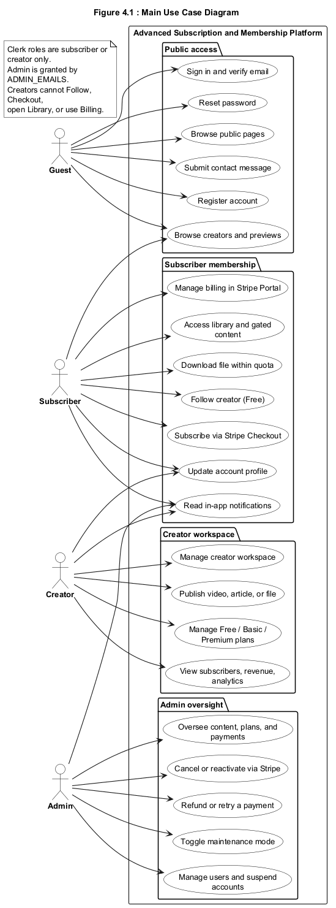
Figure 4.1: Main Use Case Diagram

Full Dress Use Case
Not every use case needs a detailed description, so only the more complex ones are written in full. Sign-up and sign-in are simple and are left as short use cases. The subscribe use case is the most important and the most detailed one, because it links the subscriber, the creator, the database, and the Stripe billing service, and because its success depends on a confirmed payment. Table 4.3 gives the full dress description of the subscribe use case.
Table 4.1: Full Dress Use Case for Subscribe to a Creator Plan
Field | Description
Use Case name | Subscribe to a creator plan
Scope | Advanced Subscription and Membership Platform
Level | User goal
Primary Actor | Subscriber
Stakeholders and Interests | The subscriber wants access to paid content; the creator wants paid members; the platform wants correct billing and access
Pre-conditions | The subscriber is signed in with a subscriber role and the chosen plan has a Stripe price
Success Guarantee | A paid subscription record exists for the subscriber and creator pair and the paid content is unlocked
Main Success Scenario | The subscriber opens the creator page, selects a paid tier, completes Stripe Checkout, and returns to unlocked content once the signed webhook confirms the payment
Extensions | If the plan has no Stripe price the checkout is refused; if the payment is cancelled no access is granted; if the account is suspended the action is blocked
Special Requirements | Payment is handled by Stripe and paid access is written only after a signed webhook event

Activity Diagram
The activity diagram describes the flow of the follow and checkout process from the subscriber's point of view. It starts when the subscriber opens a creator page and chooses either a free follow or a paid tier. A free follow writes a free membership and grants free content at once. A paid choice checks that the plan has a Stripe price, starts a Checkout session, waits for payment, and then, after the webhook confirms the payment, records the subscription and opens the paid content. The diagram also shows the safe exits, such as a blocked action for a suspended account and a cancelled checkout. The activity diagram is shown in Figure 4.2.
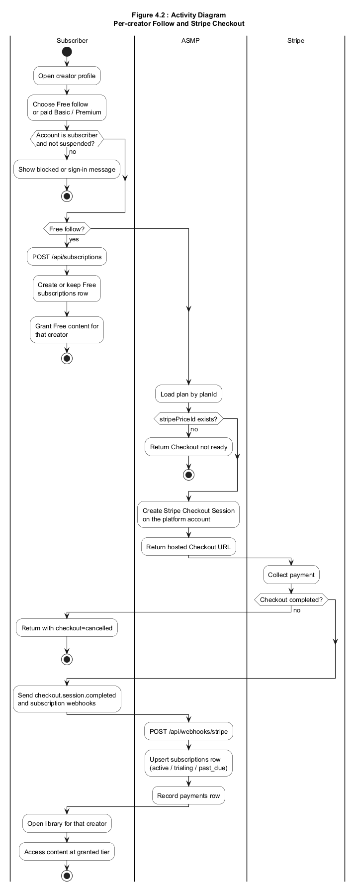
Figure 4.2: Activity Diagram

Data Flow Diagram
The data flow diagrams show how information moves through the system. They are useful here because the platform receives input from users, processes it against rules and external services, and stores the result. The level 0 diagram treats the whole platform as one process and shows how it exchanges data with the four actors and with the external services, namely Clerk, Stripe, PostgreSQL, and Cloudflare R2. The level 0 diagram is shown in Figure 4.3.
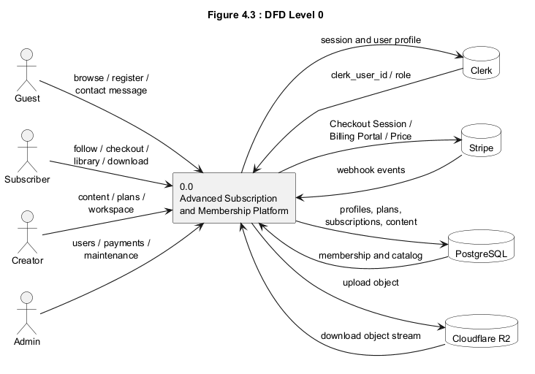
Figure 4.3: DFD Level 0
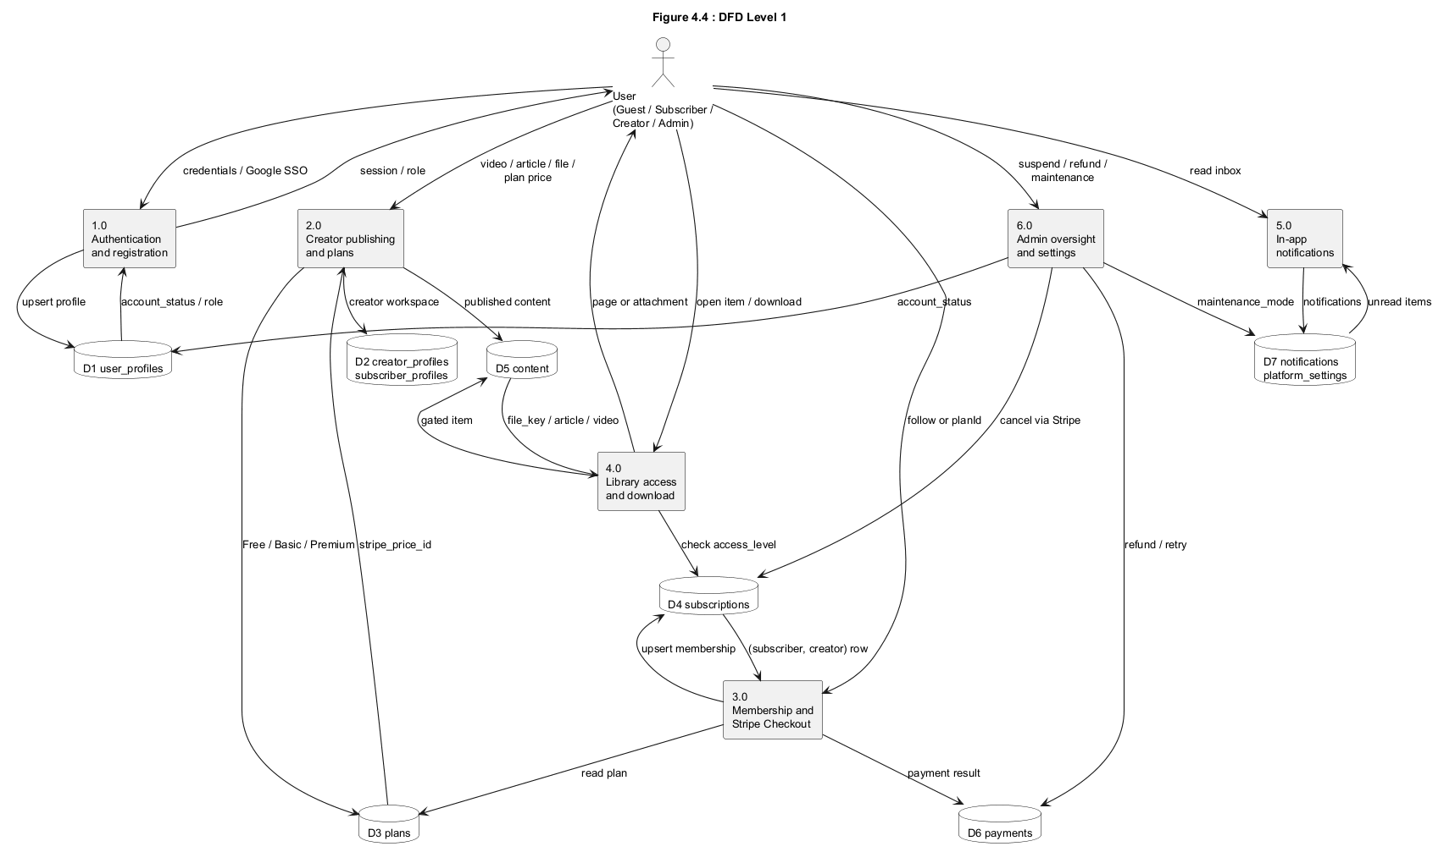
Figure 4.4: DFD Level 1

System Sequence Diagram
The system sequence diagram treats the platform as a single black box and shows the events exchanged between the subscriber and the system during the subscribe task. It covers the free follow path, the paid checkout path, and the cancel path, and it shows the order of requests and responses without exposing the internal parts. This view is drawn from the subscribe use case. The system sequence diagram is shown in Figure 4.5.
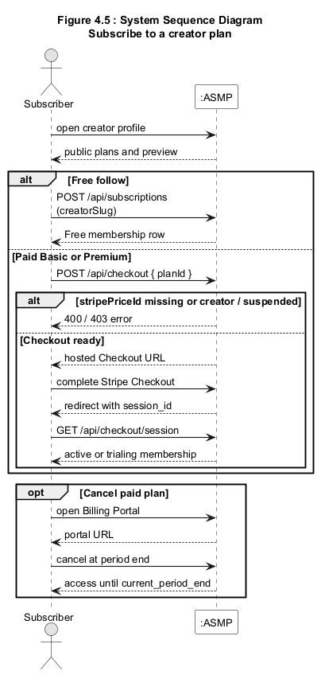
Figure 4.5: System Sequence Diagram

Sequence Diagram
The sequence diagram opens the black box and shows how the internal parts work together during a paid checkout. It shows the creator page, the checkout route, the database, the Stripe Checkout service, and the webhook route, and it shows how paid access is written only after the webhook reports that the payment is complete. This detail explains how billing state and access state are kept in step. The sequence diagram is shown in Figure 4.6.
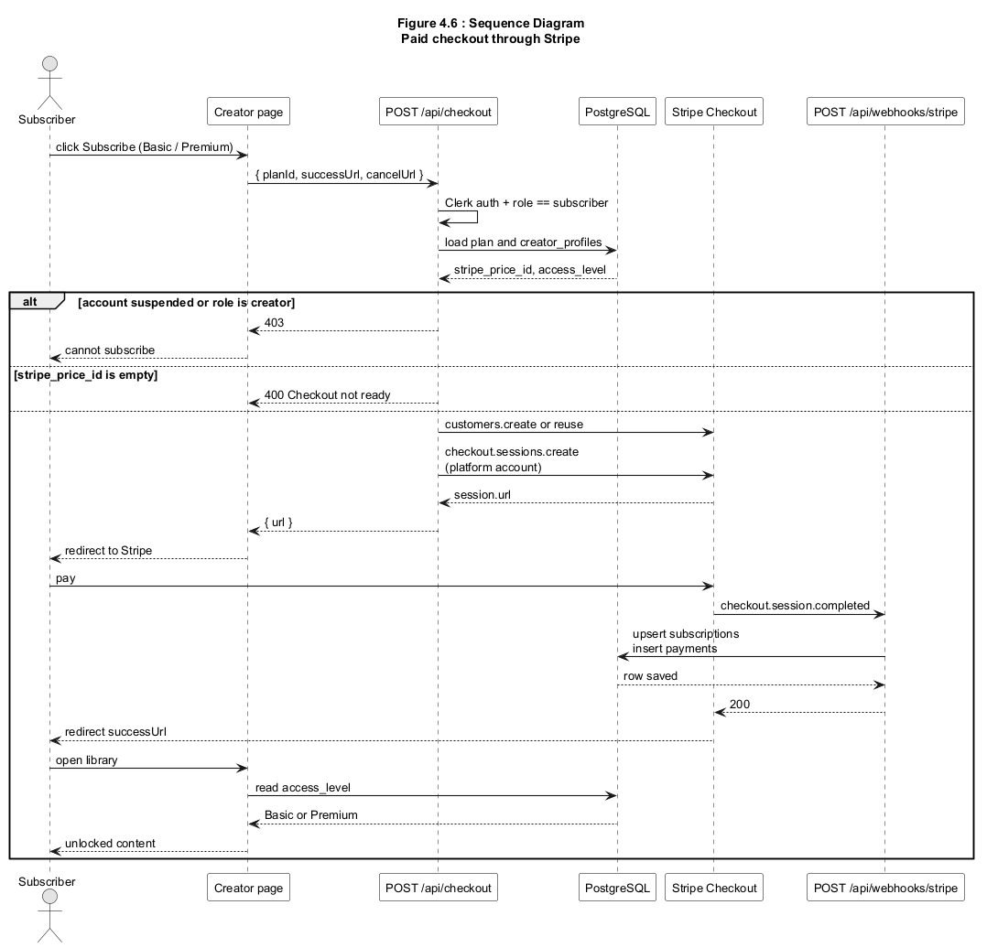
Figure 4.6: Sequence Diagram

Design Class Diagram
The design class diagram shows the structure of the stored data and the relationships between records. The main classes are the user profile, the creator profile, the subscriber profile, the plan, the content item, the subscription, the payment, the notification, and the platform settings. The diagram shows that a creator owns many plans and content items, that a subscription is unique for each subscriber and creator pair, and that a subscription can have many payments. The design class diagram is shown in Figure 4.7.
The relationships in the diagram carry the rules of the system, not only its data. The link between a subscription and a subscriber and creator pair is what makes access per creator, since a subscriber can hold one subscription with each creator and no more. The required tier on each content item, read together with the tier on the subscription, is what the access check compares before it serves an item. The link from a subscription to its payments is what lets the system show a billing history and keep the stored status in step with Stripe. Reading the class diagram in this way explains how the stored structure supports the behaviour described in the earlier models.
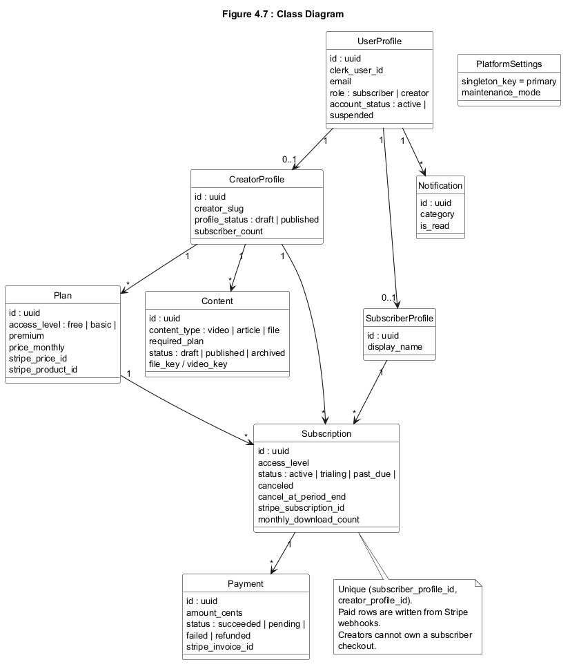
Figure 4.7 Class Diagram

Architectural Diagrams
The architectural diagrams describe the shape of the system as a whole. The project follows a layered web architecture built on the Next.js framework, where the browser talks to server-side route handlers, and the handlers talk to the database and to the external services. These diagrams are included because they make the structure and the deployment of the system clear. Three architectural views are given, namely the interface design, the component level design, and the deployment diagram.

Interface Design
The interface design diagram groups the screens of the system by the role that uses them, namely the public screens, the subscriber screens, the creator workspace, and the administrator area, and it shows how a user moves between the main pages. The interface design diagram is shown in Figure 4.8.
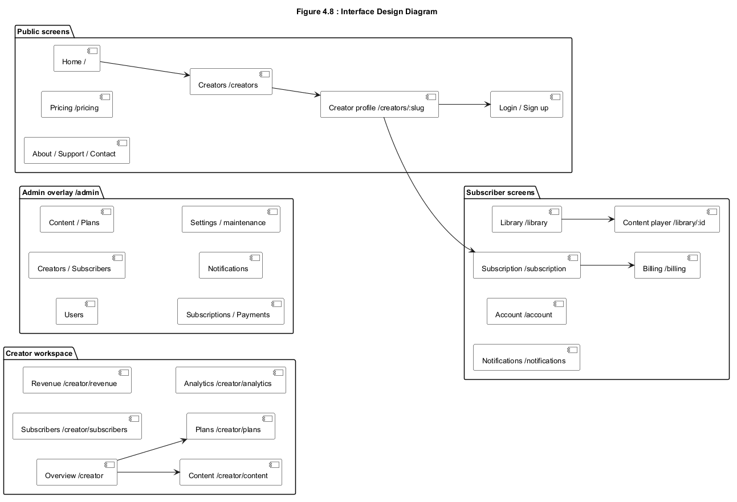
Figure 4.8 Interface Design Diagram

Component Level Design
The component level design diagram shows the internal parts of the application and how they depend on each other. It shows the browser pages, the Clerk middleware, the route handlers, the database access layer, the Stripe module, and the storage module, together with the external services they reach. The component level design diagram is shown in Figure 4.9
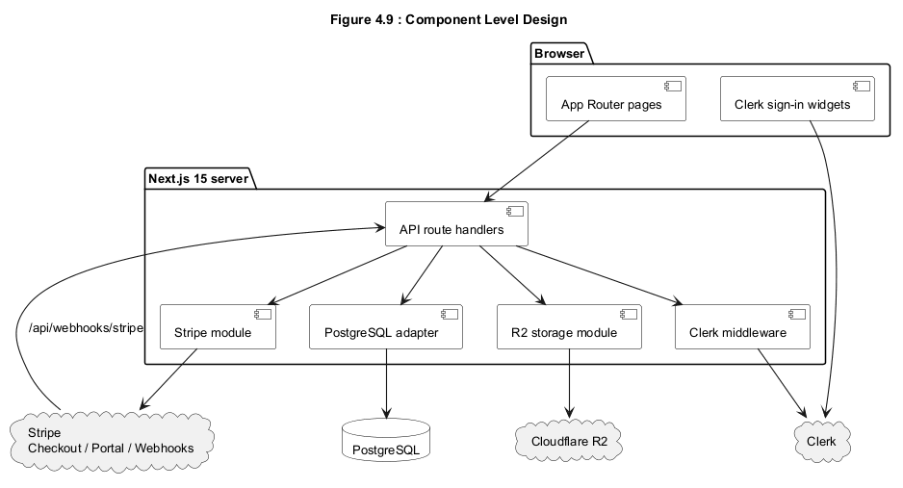
Figure 4.9 Component Level Design

Deployment
The deployment diagram shows where each part of the system runs, namely the browser on the client device, the application on a Node.js host, and the external services for authentication, billing, database, and storage. The deployment diagram is shown in Figure 4.10.
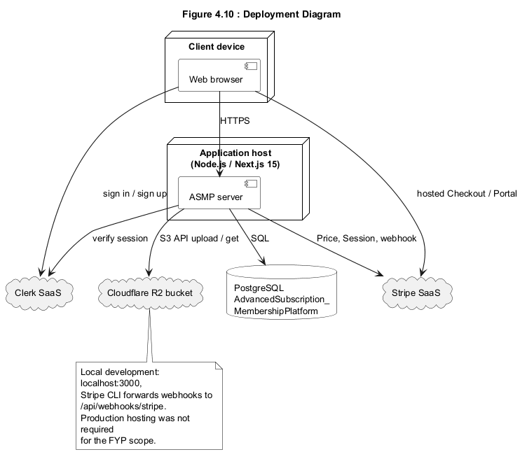
Figure 4.10 Deployment

CHAPTER 5
System Testing and Validation

This chapter describes how the system was tested and what the tests showed. It explains the testing approach, the techniques used, the test cases designed for the main features, and the results observed when the tests were run.
The chapter is organised into four sections. Section 5.1 introduces system testing and its importance. Section 5.2 describes the testing techniques used. Section 5.3 presents the test cases and their results, and Section 5.4 discusses the non-functional requirements and how they were measured.

System Testing
System testing checks that the finished parts of the software work together and meet the requirements. It matters because a membership platform must protect paid content and must keep billing and access in step, and a single missed check can either block a paying member or expose paid content. The system was tested by hand on a development machine, using Stripe test mode, by running the application and exercising each main workflow as a real user would. The overall result of this testing was that the tested workflows behaved as expected, which supports the objectives of secure access and correct billing.
The tests were run in a controlled environment that stood in for real use. The application ran locally against a PostgreSQL database, Stripe ran in test mode with test cards, and the Stripe command line tool forwarded signed webhook events to the local server so that the payment flow could be exercised end to end. Separate accounts were created for a subscriber, a creator, and an administrator, so that each role could be tested with the access it is meant to have. This setup made it possible to check the full path from sign-up through paid access, cancellation, and administration without spending real money or exposing real user data.

Testing Techniques
Two testing techniques were used, namely black box testing and functional testing. Both were carried out manually, since the project does not include an automated test suite.

Black Box Testing
Black box testing checks the system through its interface without looking at the internal code. It was chosen because the most important behaviour of this system, such as whether a lower-tier subscriber is refused a Premium file, is best judged from the outside. Each case was carried out by signing in as the relevant user, performing the action through the interface, and comparing the result with the expected outcome. The results matched the expected outcomes for the tested cases.

Functional Testing
Functional testing checks that each feature does what the requirements say. It was chosen because the requirements in Chapter 3 map directly to features that can be exercised one by one, such as following a creator, paying for a tier, and downloading a file within the quota. Each feature was run through its normal path and through at least one failure path, such as a cancelled payment, and the observed behaviour agreed with the requirement.

Test Cases
Several test cases were designed to cover the main features of the system, drawn from the functional requirements in Chapter 3. Table 5.1 summarises these test cases with their steps, expected results, actual results, and status. Two of the more important cases are then described in more detail.
Table 5.1 Summary of Test Cases
ID | Test Case | Steps | Expected Result | Actual Result | Status
TC-01 | Sign up and verify email | Register, verify the email, then sign in | Account is created and the user reaches the correct area | As expected | Pass
TC-02 | Follow a creator for free | Open a creator page and choose Follow | A free membership is recorded and free content opens | As expected | Pass
TC-03 | Pay for a paid tier | Choose Basic or Premium and complete Stripe test checkout | Paid access is granted after the webhook confirms payment | As expected | Pass
TC-04 | Tier access enforcement | As a lower-tier user, open a higher-tier item | Access is refused and only a preview is shown | As expected | Pass
TC-05 | Download quota | Download files until the monthly limit is reached | Downloads beyond the limit are stopped | As expected | Pass
TC-06 | Admin suspend account | Suspend a subscriber and try a protected action | The action is blocked while the account is suspended | As expected | Pass
TC-07 | Cancel a paid plan | Cancel a paid subscription from the account area | Access continues until the period ends, then drops to free | As expected | Pass
TC-08 | Maintenance mode | Turn maintenance mode on and open the public site | The public site shows a maintenance page while admins keep access | As expected | Pass

Test Case 1: Pay for a Paid Tier
This case tests the paid checkout feature, which is central to the system. It confirms that access is granted only after Stripe reports a completed payment. Table 5.2 gives the detail of this test case.
Table 5.2 Test Case for Paid Checkout
Field | Description
Test Case ID | TC-03
Feature tested | Paid subscription through Stripe Checkout
Pre-conditions | The subscriber is signed in and the plan has a Stripe price
Steps | Open the creator page, choose Basic or Premium, complete the Stripe test payment, and return to the site
Expected Result | The subscription record is written after the signed webhook and paid content becomes available
Actual Result | The subscription was recorded after the webhook and paid content opened
Status | Pass

Test Case 2: Download Quota
This case tests that file downloads are counted and limited by tier. It confirms that a subscriber cannot exceed the monthly download limit for a creator. Table 5.3 gives the detail of this test case.
Table 5.3 Test Case for Download Quota
Field | Description
Test Case ID | TC-05
Feature tested | Monthly download quota for protected files
Pre-conditions | The subscriber holds a tier that allows downloads and has downloads remaining
Steps | Download files one by one until the monthly limit for that creator is reached, then attempt one more
Expected Result | Downloads within the limit succeed and the next download is stopped
Actual Result | Downloads within the limit succeeded and the extra download was stopped
Status | Pass

Non-Functional Requirements
The non-functional requirements from Chapter 3 were also checked during testing, using measurable criteria rather than general statements. Security was checked by confirming that signed-out and lower-tier users could not reach protected items or files. Reliability was checked by confirming that access followed only from confirmed payments. Usability was checked by completing the main tasks as a first-time user, and performance was judged by the load time of the main pages for a single active user. Table 5.4 lists common non-functional properties and the measures used.
Table 5.4 List of Common Non-Functional Requirements
Property | Measure
Security | Number of successful access bypasses in testing, with a target of zero
Reliability | Share of tested billing events that produce the correct access outcome
Usability | Whether a first-time user completes the main tasks in a single attempt
Performance | Load time of the main pages for a single active user

CHAPTER 6
Conclusion

This chapter concludes the report. It first draws together what the project achieved, and it then discusses the limits of the current system and the work that can be done in the future.

Conclusion
The Advanced Subscription and Membership Platform set out to build a per-creator membership model where access is tied to confirmed payment and where each creator keeps a separate space. The finished system meets that goal for the defined scope. It supports sign-up and role handling through Clerk, per-creator Free, Basic, and Premium tiers, paid checkout through Stripe with access written only after a signed webhook, mixed content with per-item tiers, protected file downloads with a monthly quota, and administrative oversight of users, content, payments, and settings. Manual functional and black-box testing of these workflows produced the expected results, which shows that the access rules and the billing flow work together as intended. The project therefore demonstrates a complete and working membership service from sign-up through paid access and administration.
Beyond the working features, the project met its wider aim of showing how several separate concerns can be joined into one clear service. Authentication, billing, storage, and access control each came with its own rules and its own external service, and the main work of the project was to make them agree with one another rather than to build any one of them alone. The design keeps a single source of truth for tier limits, checks access on the server, and writes paid access only after a confirmed payment, and these three choices together explain why the tested behaviour stayed correct. The result is a system that a small creator could use in practice and that also serves as a clear study of the membership model it was built to explore.

Limitations and Future Work
The current system has clear limits. It runs against Stripe test mode and a single database, it has no automated test suite, and it does not handle creator payouts or a single plan that unlocks every creator at once. Its testing was manual, so it does not yet have repeatable automated checks. These limits can be addressed as future work. An automated testing layer would make checks repeatable and would catch regressions early. Support for creator payouts would let the platform move money to creators rather than only collecting it on one account. Production hosting, wider analytics, and a review of performance under many users would prepare the system for real use. With these additions, the platform could grow from a working project into a service ready for a live audience.

References
[1] Vercel, "Next.js Documentation." https://nextjs.org/docs (accessed September 2026).
[2] Stripe, "Stripe Documentation: Checkout and Webhooks." https://stripe.com/docs (accessed September 2026).
[3] Clerk, "Clerk Documentation: Authentication for Next.js." https://clerk.com/docs (accessed September 2026).
[4] The PostgreSQL Global Development Group, "PostgreSQL Documentation." https://www.postgresql.org/docs/ (accessed September 2026).
[5] Cloudflare, "Cloudflare R2 Documentation." https://developers.cloudflare.com/r2/ (accessed September 2026).
[6] R. S. Sandhu, E. J. Coyne, H. L. Feinstein, and C. E. Youman, "Role-Based Access Control Models," IEEE Computer, vol. 29, no. 2, pp. 38-47, 1996. doi: 10.1109/2.485845.
[7] F. Chong and G. Carraro, "Architecture Strategies for Catching the Long Tail," MSDN Library, Microsoft Corporation, April 2006. https://learn.microsoft.com/en-us/previous-versions/dotnet/articles/aa479069(v=msdn.10) (accessed September 2026).
[8] E. Ascarza, "Retention Futility: Targeting High-Risk Customers Might Be Ineffective," Journal of Marketing Research, vol. 55, no. 1, pp. 80-98, 2018. doi: 10.1509/jmr.16.0163.

